 The Islamia University Of Bahawalpur
Department of Management Sciences

Project : Stack Based Text Editor (I’D 1)

Course Title:
Data Structure & Algorithms

26th May, 2024
Class: Semester: Date:
BSCS
3rd

Submitted to: Submitted by:
Usman Ghani Abdul Quddos
Roll No: 1165
Sharif Hassan
Roll No: 1260
Danil Waqeel
Roll No: 1173

Stack Bases Text Editor (I’D 1)

#include <iostream>
#include <stack>
#include <string>

using namespace std;

class TextEditor {
private:
string text;
stack<string> undoStack;
stack<string> redoStack;

public:
TextEditor() {
text = "";
}

void insert(char c) {
undoStack.push(text);
text += c;
while (!redoStack.empty()) redoStack.pop();
}

void remove() {
if (!text.empty()) {
undoStack.push(text);
text.pop_back();
while (!redoStack.empty()) redoStack.pop();
}
}

void undo() {
if (!undoStack.empty()) {
redoStack.push(text);
text = undoStack.top();
undoStack.pop();
}
}

void redo() {
if (!redoStack.empty()) {
undoStack.push(text);
text = redoStack.top();
redoStack.pop();
}
}

void display() const {
cout << "Text: " << text << endl;
}
};

int main() {
TextEditor editor;
editor.insert('H');
editor.insert('e');
editor.insert('l');
editor.insert('l');
editor.insert('o');
editor.display();

editor.remove();
editor.display();

editor.undo();
editor.display();

editor.redo();
editor.display();

return 0;
}

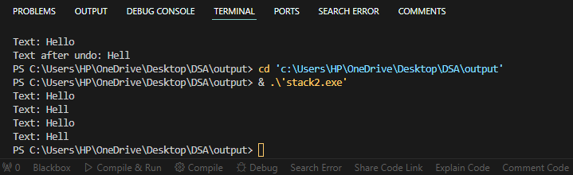

Explanation:

The program simulates a basic text editor functionality with support for inserting characters, removing characters, undoing changes, redoing changes, and displaying the current text.
Components:
TextEditor Class:
Manages the text and operations.
Main Function:
Demonstrates the usage of the TextEditor class.
TextEditor Class Functions:
1. Insert Character:
Function: void insert(char c)
Input: Character c to be inserted.
Description: Inserts a character at the end of the text.
Output: Updates and displays the text with the inserted character.
2. Remove Character:
Function: void remove()
Input: None
Description: Removes the last character from the text if it's not empty.
Output: Updates and displays the text after removal.
3. Undo Operation:
- Function: void undo()
- Input: None
- Description: Reverts the text to the previous state.
- Output: Updates and displays the text after undoing.
4. Redo Operation:
- Function: void redo()
- Input: None
- Description: Reapplies the undone change.
- Output: Updates and displays the text after redoing.
5. Display Text:
- Function: void display() const
- Input: None
- Description: Prints the current text.
- Output: Displays the text on the console.
Main Function Execution:
1. Insert Characters:
- Inserts characters 'H', 'e', 'l', 'l', 'o' into the text.
- Output: Displays the text "Hello".
2. Remove Character:
- Removes the last character ('o') from the text.
- Output: Displays the updated text "Hell".
3. Undo Operation:
- Undoes the last change (removal of 'o').
- Output: Displays the reverted text "Hello".
4.Redo Operation:
- Redoes the undone change (removal of 'o').
- Output: Displays the updated text "Hell".

